**TASK 10: VALIDATION**

**Industrial Processes: The Contact Process**

Score:

_________/36

Time allowed: 40 minutes

Name: _______________________________

**Complete all questions in the space provided.**

**The following passage provides a summary of the Contact Process**

The Contact Process is used in the manufacture of sulfuric acid. The process involved three main steps:

**Step 1: Production of sulfur dioxide**

This can be completed in one of two ways

Sulfur is burnt in excess oxygen (air)

$$S \left(s\right)+O_{2} \left(g\right)→SO_{2} (g)$$

**Sulfide ores like pyrite are heated in air**

$$4FeS_{2} \left(s\right)+11O_{2} \left(g\right)→2Fe_{2}O_{3} \left(s\right)+8SO_{2} (g)$$

**Step 2: Conversion of sulfur dioxide into sulfur trioxide**

This is a reversible exothermic reaction

$$2SO_{2}\left(g\right)+O_{2}\left(g\right)⇌2SO_{3}\left(g\right) ΔH=-196kJ/mol$$

See the flowchart for this stage below

400-450°C

2 atm

V2O5 catalyst

Sulfur trioxide

Sulfur dioxide

+ oxygen

**Step 3: Converting sulfur trioxide to sulfuric acid**

This stage is completed in two steps, this is done to avoid producing a sulfuric acid fog

Firstly, the sulfur trioxide is dissolved in existing sulfuric acid

$$H_{2}SO_{4} \left(l\right)+SO_{3} \left(g\right)→H_{2}S_{2}O_{7} (l)$$

The product, fuming sulfuric acid or oleum, is then safely reacted with water

$$H_{2}S_{2}O_{7} (l)+H_{2}O(l)→2H_{2}SO_{4}(l)$$

**Question 1 7 marks**

The Contact Process can be represented by the three equations below

$$S \left(s\right)+O_{2} \left(g\right)→SO_{2} (g)$$

$$2SO_{2}\left(g\right)+O_{2}\left(g\right)⇌2SO_{3}\left(g\right)$$

$$SO_{3}\left(g\right)+ H_{2}O\left(l\right)→ H_{2}SO_{4}(l)$$

(a) write an **overall** chemical equation for the Contact Process reactions above. (2 marks)

(b) calculate the mass of sulfuric acid that can be produced from 1.00 x 103 L of oxygen gas at S.T.P assuming the process is only 98.0% efficient. Express your final answer to the correct numberof **significant figures**. (5 marks)

**Question 2 and 3 refer to the conversion of sulfur dioxide into trioxide in step 2.**

$$2SO_{2}\left(g\right)+O_{2}\left(g\right)⇌2SO_{3}\left(g\right) ΔH=-196kJ/mol$$

**Question 2 5 marks**

The typical operating conditions for this step are described on page one of this task.

Using knowledge of reaction rates and Collision Theory, explain the effect of the **high pressure** stated above on the **rates** and **theoretical** **yield** of sulfur trioxide gas.

|  |
| --- |
|  |
|  |
|  |
|  |
|  |
|  |
|  |
|  |
|  |

**Questions 3 4 marks**

State the effect of the following imposed changes on the equilibrium system above.

|  |  |  |  |
| --- | --- | --- | --- |
| **Imposed change** | **Effect on the rate of the forward reaction**  (write increase, decrease or no change) | **Effect on the yield of SO3**  (write increase, decrease or no change) | **Effect on the value of K**  (write increase, decrease or no change) |
| Temperature is increased to 600oC |  |  |  |
| The partial pressure of SO2 is increased |  |  |  |
| Volume of reaction vessel is increased |  |  | **No change** |

**Question 4 2 marks**

Calculate the atom economy for the reaction:

$$4FeS_{2} \left(s\right)+11O_{2} \left(g\right)→2Fe_{2}O_{3} \left(s\right)+8SO_{2} (g)$$

where the desired product is sulfur dioxide. The relevant mathematical relationship is shown below.

**Atom economy = total molar mass of atoms in desired product x 100**

**total molar mass of atoms in all reactants**

**Question 5 11 marks**

A devout ‘Green’ chemist, after years of research, believed that he and his team of chemists had discovered a protein mixture to catalyse the reaction mentioned in Step 2. Apart from a faster rate of reaction, this biological catalyst would reduce heating needs and usage of non-renewable fossil fuels for heating.

A chemical species, **X**, found in the protein mixture has the structure shown below.

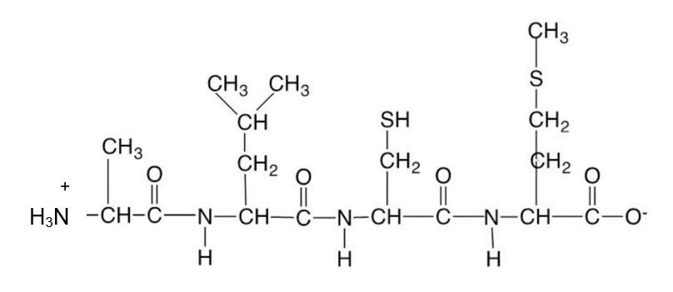

(a) Identify the amino acids in **X**. Use symbols to write the correct sequence of amino acids in **X** from left to right (e.g. Ala – Arg – Asn etc.) (2 marks)

**­**_______________________________________________________________________________

**For parts (b) and (c), circle one option.**

(b) The aqueous solution containing **X** is most likely to have a pH of

(1 mark)

1. 0

(ii) 2

(iii) 7

(iv) 12

(c) In an aqueous solution of **X**, what would be the **strongest** form of interaction between **X** and water molecules? (1 mark)

1. Hydrogen bonds.

(ii) Dipole-dipole interaction.

(iii) Ion-dipole interaction.

(iv) Ionic attraction

(d) Another chemical species found in the catalyst mixture is the α-amino acid **valine**.Draw the structure of valine in a **solution** having a pH of 10. (1 mark)

|  |
| --- |
|  |

(e) Use the Chemistry Data Sheet provided to determine the **most dominant** interaction that may be formed between adjacent - R groups of the two polypeptides below. The interactions of interest are shown by the numbers **1, 2 and 3** in the diagram below.

(3 marks)

**Ser – Cys – Met – Thr**

**½ ½ ½**

**R R R**

**1 2 3**

**R R R**

**½ ½ ½**

**Gly – Cys - Val – Ser**

Name of dominant interaction shown by number 1: ___________________

Name of dominant interaction shown by number 2: ___________________

Name of dominant interaction shown by number 3: ___________________

After a series of repeated trials, a team member advised the ‘Green’ chemist that the biological catalyst may not be suitable. This advice was based on the photographs below showing the same protein structure at 35oC and at 42oC.

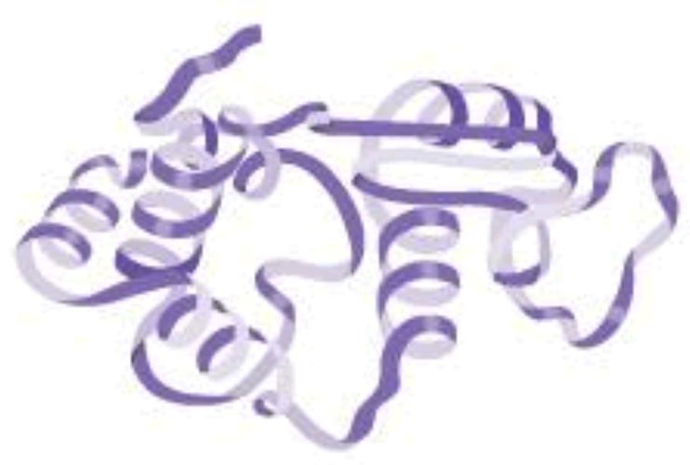 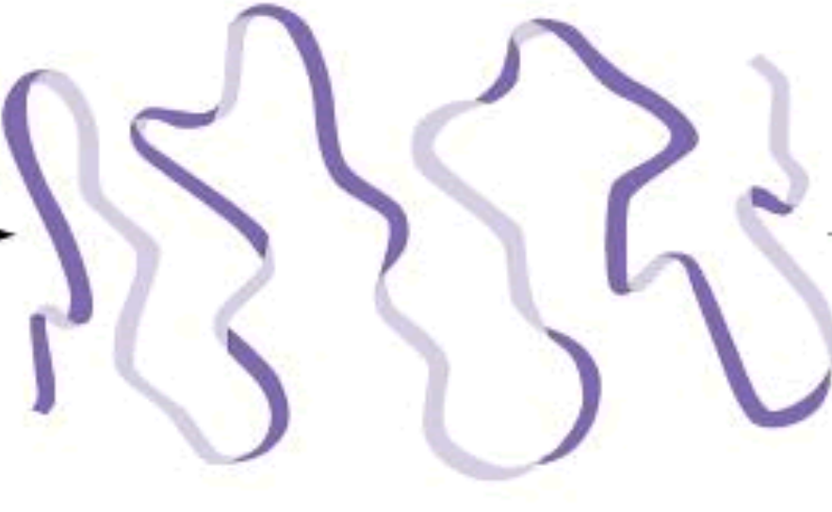

At 35oC At 42oC

(f) With reference to your knowledge of protein structures, explain what has happened to the protein in the images above. (3 marks)

|  |
| --- |
|  |
|  |
|  |
|  |

**The following question refers to the production of oleum in Step 3.**

**Question 7 7 marks**

**The chemical equation for the process is $$H_{2}SO_{4} \left(l\right)+SO_{3} \left(g\right)→H_{2}S_{2}O_{7} (l)$$**

In an efficiency trial, 0.40 g of sulfuric acid is allowed to react with 100.0 mL of sulfur trioxide at 200.0oC and 100.0 kPa. Determine

(a) the limiting reactant. (3 marks)

(b) In a separate trial, 3.00g of sulfuric acid was reacted with sulfur trioxide. Given that the actual mass of 3.00g of oleum was produced, calculate the percentage yield of this trial.

(4 marks)

**END OF PAPER**